- Sign up for a free Jira account (cloud version), create a new project using the Scrum template, and take a screenshot of your empty Scrum board.
Ans=>
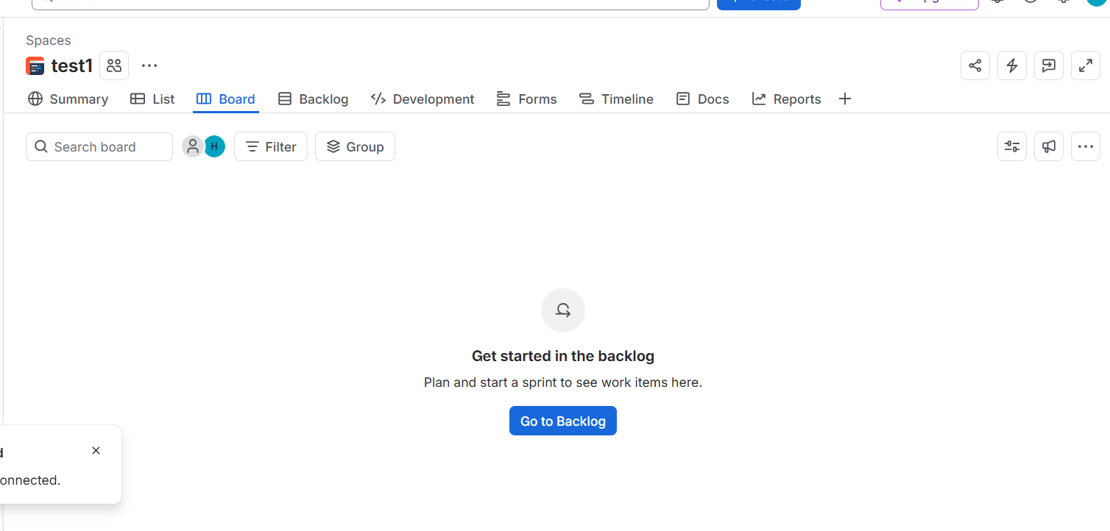

- In your Jira Scrum board, create an epic named 'Food Delivery App Features' and add three user stories under it: 'As a user, I want to search for restaurants', 'As a user, I want to track my order in real-time', and 'As a user, I want to pay using UPI'.
Ans=>
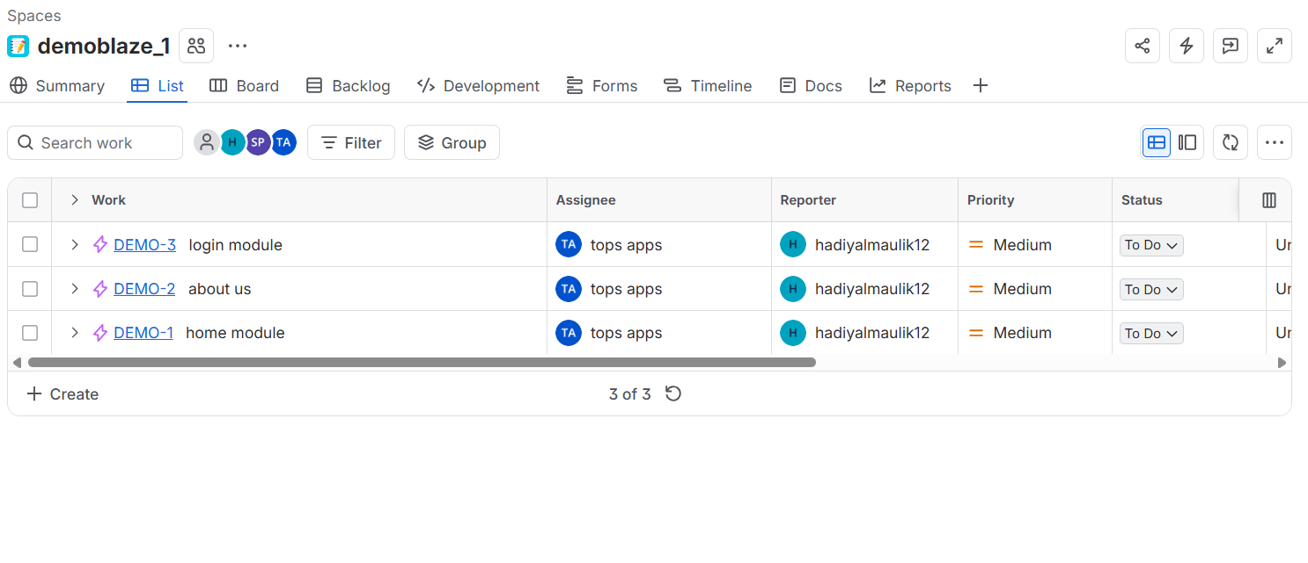

- For the user story 'As a user, I want to search for restaurants', add two sub-tasks: 'Design search UI' and 'Integrate restaurant API'.
Ans=>
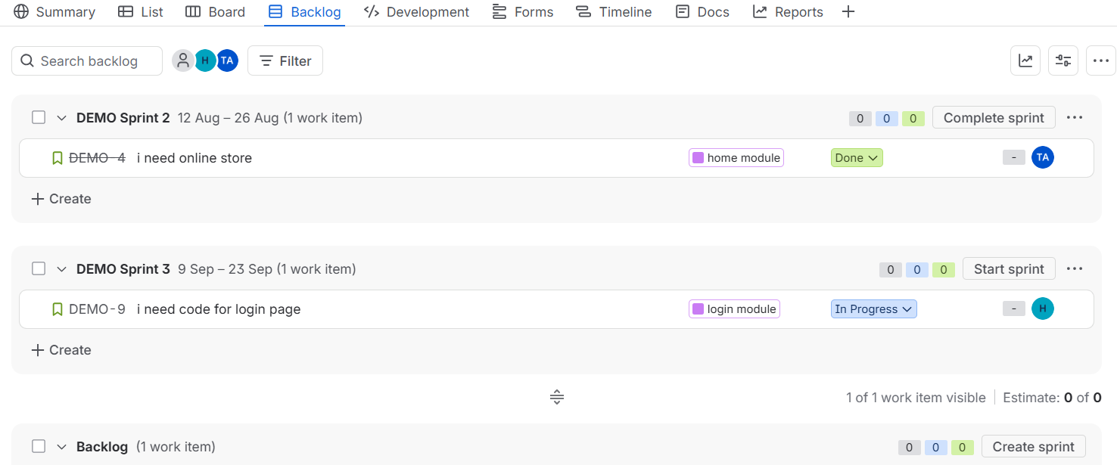

- Change the status of one of your sub-tasks from 'To Do' to 'In Progress' and then to 'Done' using the Jira board workflow.<br><br><em><strong>Hint:</strong> Drag and drop the task across columns to update its status.</em>
Ans=>
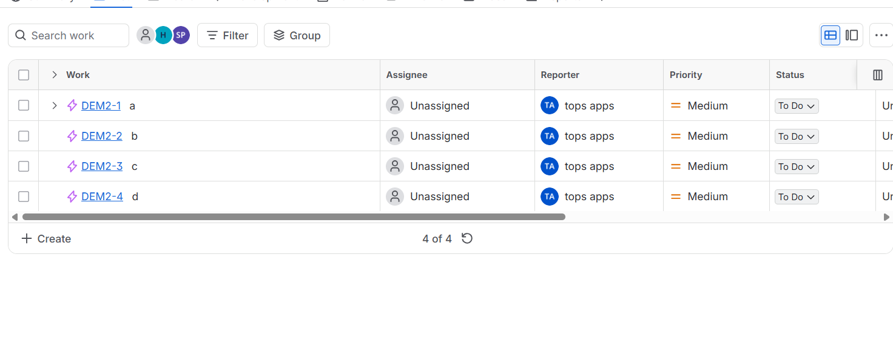

- Explore the different issue types available in Jira (Epic, Story, Task, Bug). For each type, create a sample issue in your project and write one line explaining when you would use that issue type in a real Zomato or Swiggy-like app.
Ans=>

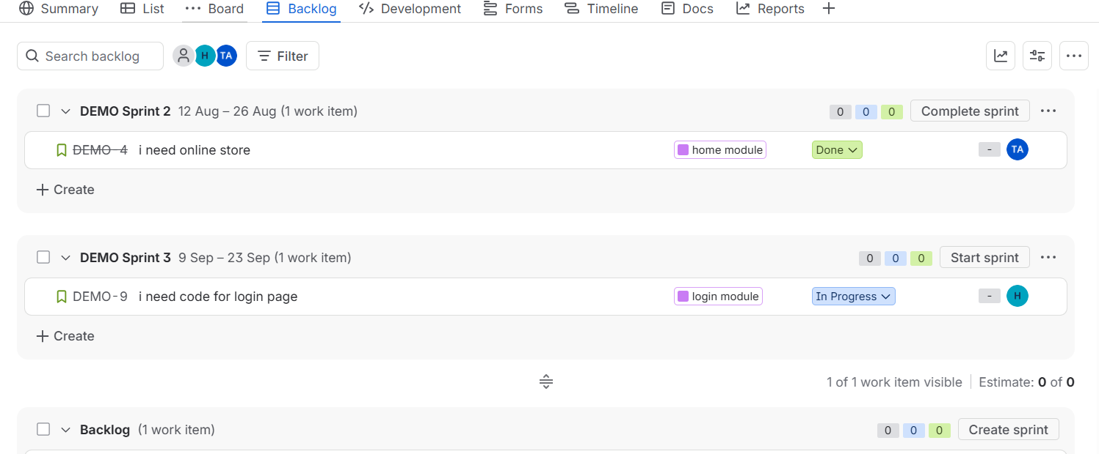

Epic | EPIC: Improve Food Delivery Tracking | Use an Epic for a large feature or goal that contains multiple related Stories and Tasks.
Story | STORY: Track delivery partner on map | Use a Story for a user-facing feature that delivers value to the customer.
Task | TASK: Integrate Google Maps API | Use a Task for a specific piece of work that needs to be completed but isn't necessarily a user story.
Bug | BUG: Delivery location marker shows wrong position | Use a Bug when existing functionality is broken or behaving incorrectly.

